Reviewer Note: Reviews for this pattern are due Sept 21st.
Generic Attribute Access

An entity bean client needs to access the attributes of an entity bean.
How can an entity bean client efficiently access and manipulate the attributes of an entity bean in a bulk, generic fashion?
* * *
The usual practice for accessing entity beans is through either Local Interface get/set methods (for entity beans written for EJB 2.X and up) or via bulk Data Transfer Objects off of the Remote Interface (for EJB 1.X entity beans). With the former, methods on the Session Façade or Data Transfer Object Factory interact with the entity bean by calling multiple fine-grained getters and setters, in order to access and manipulate attributes, as required by the particular use case. Through the latter, Data Transfer Objects are used to access and manipulate entity bean state in bulk, in order to minimize network calls associated with communication with the remote interface. Using DTOs as a mechanism to manipulate entity beans was a common pattern used to optimize communications with EJB 1.X entity beans.
The tradeoff of using DTO’s to access EJB 1.X entity beans is reduced maintainability of the entity bean layer (see the DTO Factory pattern). With the advent of EJB 2.0, local interfaces allow the extraction of DTO creation and consumption logic into a Data Transfer Object Factory; here the DTO factory interacts with an entity bean via fine-grained get/sets on the Local Interface, alleviating some of the problems with using DTO’s.
Unfortunately, EJB 1.X entity beans do not Local Interfaces. The consequence of this is that DTO creation/consumption logic cannot be extracted from an entity bean to DTO factory (because it is bad for performance for a DTO factory to make multiple fine-grained calls on an entity beans remote interface). Some other mechanism is needed, one that will allow bulk access to entity bean data through the remote interface, without cluttering it with DTO creation/consumption logic.
Even with EJB 2.0, there are cases in which exposing multiple fine-grained get/set methods on the Local Interface is not a good idea:
Does not scale well from small to large entity beans. Imagine a stock/bonds entity bean for a financial application. Such an entity bean could have well over 200 attributes. To write and expose getters/setters for all of those attributes could be a nightmare of tedious coding and an explosion in interface size.
Results in tightly coupled, hard-coded clients. Entity bean clients (such as the Session Façade) need to be tightly coupled to the interface of the entity bean, making sensitive to even minute changes that can frequently occur – such as the adding or removing of an attribute.

The takeaway point is that some other mechanism is needed to access entity bean data, one that that can allow a DTO factory to use the Remote Interface to dynamically grab different subsets of entity bean state in one bulk network call, and also help decouple entity bean clients from an entity beans attribute accessors, when using a Local Interface.
Therefore,
Abstract entity bean attribute access logic into a generic Attribute Access interface, using HashMaps to pass key-value attributes in and out of entity beans.
The Attribute Access interface is implemented by entity beans on the Remote or Local interface, and looks like this:

public interface AttributeAccess {
public Map getAttributes(Collection keysOfAttributes);
public Map getAllAttributes();
public void setAttributes(Map keyAndValuePairs);
}

Source x.x: Attribute Access Interface

Attribute Access provides a generic interface that allows arbitrary sets of data to be get or set from an entity bean dynamically. The interface allows EJB 1.X entity beans to use a DTO Factory to extract DTO creation logic and optimize on remote calls, as well as allowing EJB 2.X entity beans to simplify their Local Interfaces by removing the need for fine-grained get/set methods. The only dependency been client and entity bean code is the naming conventions placed on the keys used to identify attributes, described later in this pattern.
The Session Façade or DTO Factory can access an entity beans attributes through the attribute access interface. Figure X.1 illustrates a typical case. Here, a client is interested in gathering a subset of the data of a “Car” entity bean relating to its engine. A client calls the getCarEngineData method on the session façade, which in turn asks an entity bean for the exact attributes that are part of the car engine, by first creating a collection that includes the key values of the attributes of interest (horsepower, volume, etc), then passing this collection to the getAttributes(collection) method on the entity bean, which will return a HashMap with this exact subset.
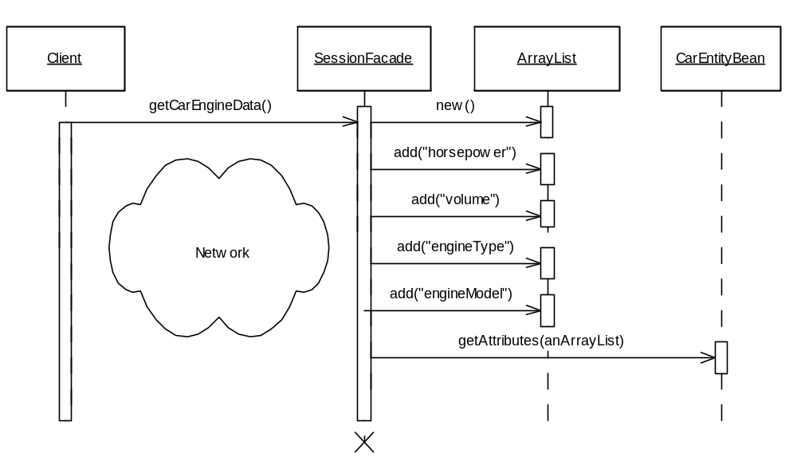
Figure X.1: Using the AttributeAccess Interface

After receiving the populated HashMap from the Car entity bean, the session bean can:
- Return the HashMap to a remote client. Here the session bean uses the HashMap as serializable container for transferring data across the network (as described in the Data Transfer HashMap pattern).
- Convert HashMap into a DTO and return it. As a DTO Factory, the session bean can extract the values of the HashMap and add them to a Data Transfer Object, returning the DTO to the client.
Which option to choose, is up to the developer. As a mechanism for data transfer, HashMaps provide many advantages over Data Transfer Objects (as described in the Data Transfer HashMap pattern), but also come at the expense of significant additional complexity. If the Attribute Access interface is used behind a DTO factory, dependencies between key/value names can be kept localized to the server, where the session beans need to be aware of the entity beans anyway.
Using the attribute access interface, a session bean can thus dynamically decide which subsets of entity bean data it requires at run time, eliminating the need for manual, design time programming of Data Transfer Objects.
Like the interface itself, the implementation of the AttributeAccess interface is generic. Under BMP, an entity bean can be further simplified by storing all of its attributes in a private, internal HashMap, rather than the obvious hard-coding of attributes that usually takes place. On large entity beans, this optimization can simplify an entity beans code greatly. Using this internal HashMap, the implementation of the methods on AttributeAccess thus become completely generic, reusable across BMP entity beans:

private java.util.HashMap attributes;

/**
* Returns key/value pairs of entity bean attributes
* @return java.util.Map
*/
public Map getAllAttributes()
{
return(HashMap)attributes.clone();
}

/**
* Used by clients to specify exactly the attributes they are interested in
* @return java.util.Map
* @param keysofAttributes the name of the attributes the client is
* interested in
*/
public Map getAttributes(Collection keysofAttributes)
{
Iterator keys = keysofAttributes.iterator();
Object aKey = null;
HashMap aMap = new HashMap();

while ( keys.hasNext() )
{
aKey = keys.next();
aMap.put( aKey, this.attributes.get(aKey));
}

//map now has all requested data
return aMap;
}

/**
* Used by clients to update particular attributes in the entity bean
* @param keyValuePairs java.util.Map
*/
public void setAttributes(Map keyValuePairs)
{
Iterator entries = keyValuePairs.entrySet().iterator();
Map.Entry anEntry = null;

while ( entries.hasNext() )
{
anEntry = (Map.Entry)entries.next();
this.attributes.put(anEntry.getKey(), anEntry.getValue());
}
}
Source X.2: Attribute Access BMP Implementation

In CMP, using an internal map of attributes is not possible, since the implementation of an entity beans classes is abstracted behind container generated get and set methods. When an internal map is not possible, the AttributeAccess interface can be implemented generically using the Java Reflection API. That is, in setAttributes, reflection can be performed on the key-value of the attribute a client wants to set. That is, if the key-value is XXX the setAttribute implementation will attempt to call setXXX(…) on the entity bean. Similarly, in the getAttributes method, reflection can be used to find all get methods on an entity bean, invoke them and populate a map for the client. If a developer would prefer not to use the Reflection API, then implementing the AttributeAccess method cannot be done generically for CMP. The developer will need to interlace his AttributeAccess implementation with IF statements that call hard coded get/set methods on the entity bean, depending on the key-value string.
In order to make the AttributeAccess implementation code reusable across all entity beans, a super class can be used to implement the interface methods, which are completely generic whether using the reflection method or the internal map of attributes style of implementation. All entity beans wanting to make use of the AttributeAccess services need only subclass the super class implementation, thus automatically exposing this unified interface to their attributes with no extra coding involved.
The final piece of the puzzle is how to name the keys, which identify the attributes of an entity bean. Not only do the attributes need to be identified by key, but client and server side programmers must need to agree on the naming conventions. Some sort of ‘contract’ is required between client and server. Several possibilities are discussed:
Establish a consistent naming convention. The client and the server can agree upon a documented, consistent naming convention for attributes. For an Account entity bean, “com.bank.Account.accountName”, or simply “accountName” would be an example of consistent convention. The drawback with this approach is that the contract exists in the minds of developers only, when developing, it is easy to misspell the attribute name, resulting in costly development errors.
Define static final member variables in the entity bean remote or local interface. An entity bean client can make calls to the entity bean using references to static final variables containing the correct key-string required to get an attribute. For example, in-order to retrieve the attributes from an Employee entity bean; a session bean could use the following code:
//ask employee for his personal attributes
Collection aCollection = new ArrayList();
aCollection.add(Employee.NAME);
aCollection.add(Employee.EMAIL);
aCollection.add(Employee.SEX);
aCollection.add(Employee.SSN);

Map aMap = employee.getAttributes(aCollection);
Source X.3: Getting attributes using final static variables
Where the entity beans local interface contains the following definitions:
public interface Employee extends EJBLocalObject, AttributeAccess
{

//since attributes are stored in a hashmap in the entity bean,
//we need a central place to store the 'keys' used to reference
//attributes, so that the clients and the entity bean won't need
//need to be hardcoded with knowledge of the attribute key strings
public final static String ID = "EMPLOYEEID";
public final static String NAME = "NAME";
public final static String EMAIL = "EMAIL";
public final static String AGE = "AGE";
public final static String SSN = "SSN";
public final static String SEX = "SEX";
...
}

Source X.4: A Local Interface Attribute Contract
This approach works great for the DTO factory approach, where a session bean is querying the entity bean directly for its attributes, with the intention of returning a hard coded Data Transfer Object to the client, instead of a HashMap. Here, only the session bean and the entity bean need to agree on the names of the attribute keys, making the Local/Remote interface a good place to localize names of the attributes. This approach breaks down when using the Data Transfer Hashmap pattern, since the clients also needs to know the names of the key values, but the client does not have access to the entity bean’s remote/local interface.
Shared class with static final member variables. Here we can create a class that is shared by both the client classes and the server classes, which is used to encapsulate the actual strings used to populate and read strings from a HashMap behind a hard coded final static variable, accessible by both client and server. For example, a client would query a hashmap for an attribute as follows:
accountMap.get(Names.ACCOUNTBALANCE)
Where the shared class called Names would look like:
public class Names {

public final static String ACCOUNTBALANCE = "BALANCE";
...
}
One disadvantage to this method is that should the key mappings need to be updated or added to, the new class would need to be redistributed to the client (and their JVM would thus need to be restarted).
Place the Attribute contract in a JNDI tree. In this approach, a singleton of sorts is maintained by placing a class containing the keys in a JNDI tree, accessible by client and server. Client and server code would not need to be recompiled or rebooted, when keys are changed/updated, since a central object in a JNDI tree would always contain the freshest copy of keys. The tradeoff with this solution is the overhead incurred in grabbing the contract from the JNDI tree whenever key values are required.

The Generic Attribute Access pattern has many advantages:
One interface across all entity beans. Entity bean clients can manipulate entity beans consistently via the AttributeAccess interface, simplifying client code. Entity beans are also simplified, as the AttributeAccess can be encapsulated in a super-class.
Scales well to large entity beans. Whether an entity bean has 20 or 2000 attributes, attribute access logic is simplified to just a few lines.
Low cost of maintenance over time. New views of server side data can be created that does not require any server side programming. Clients can dynamically decide which attributes to display.
Allows for dynamic addition of attributes at runtime. When using BMP, this pattern can easily be extended to allow for the ability to add and remove attributes from an entity bean dynamically. This can be achieved by adding an addAttribute and removeAttribute method to the interface, which simply performs operations on the attribute HashMap.

Like all patterns, using Generic Attribute Access has its tradeoffs:
Additional Overhead per method call. For each attribute call, clients must use an attribute key to identify attributes. Finally, attributes need to be cast to their appropriate type after being extracted from the HashMap object.
Need to maintain a contract for attribute keys. Since attributes are requested by string, clients need to remember the key strings used to identify attributes. Defining a key-attribute contract (discussed earlier in this pattern), can alleviate these dependencies.
Loss of strong typing/compile time checking. Using DTOs, values passed by gets or sets were always of the correct type, any errors would be passed at compile time. Using Generic Attribute Access, attribute access must be managed by the client at runtime by casting objects to their correct type and associating the correct attribute type with the correct key.

Overall, the Generic Attribute Access provides a generic method of managing the state of entity beans, eliminating the bulky repetitive code associated with domain specific entity bean data access.

